Colour analysis and image processing applied in fruit analysis

A Project Report

Submitted in the partial fulfilment of the requirement for the Award of the degree of

Bachelor of Technology in

Department of Computer Science and Engineering

By

BELLAM KEERTHANA (2010030017)

M.NISSIE (2010030095)

M.SRAVANI CHOWDARY (2010030104)

P. MOUNIKA REDDY (2010030485)

Under the supervision of

# Mr. Chanda Rajkumar

# Assistant Professor,CSE



Department of Computer Science and Engineering

K L University Hyderabad,

Aziz Nagar, Moinabad Road, Hyderabad – 500 075, Telangana, India.

May, 2022

# DECLARATION

The Project Report entitled “COLOUR ANALYSIS AND IMAGE PROCESSING APPLIED IN FRUIT ANALYSIS” is a record of bonafide work of BELLAM.KEERTHANA (2010030017), M.NISSIE (2010030095), M.SRAVANI CHOWDARY (2010030104), P.MOUNIKA REDDY (2010030485), submitted in partial fulfilment for the award of B.Tech in the Department of Computer Science and Engineering to the K L University, Hyderabad. The results embodied in this report have not been copied from any other Departments/ University/ Institute.

BELLAM KEERTHANA (2010030017)

M.NISSIE (2010030095)

M.SRAVANI CHOWDARY(2010030104)

P. MOUNIKA REDDY (2010030485)

# CERTIFICATE

This is to certify that the Project Report entitled “COLOR ANALYSIS AND IMAGE PROCESSING APPLIED IN FRUIT ANALYSIS” is a record of bonafide work of BELLAM KEERTHANA (2010030017), M.NISSIE (2010030095), M.SRAVANI CHOWDARY (2010030104), P.MOUNIKA REDDY (2010030485),submitted in partial fulfilment for the award of B.Tech in CSE to the K L University, Hyderabad is a record of bonafide work carried out under our guidance and supervision.

The results embodied in this report have not been copied from any other departments/ University/Institute.

### Signature of the Supervisor

Mr. Chanda Rajkumar

Assistant Professor, CSE

**Signature of the HOD Signature of the External Examiner**

# ACKNOWLEDGEMENT

First and foremost, we thank the lord almighty for all his grace & mercy showered upon us, for completing this project successfully.

We take grateful opportunity to thank our beloved Founder and Chairman who has given constant encouragement during our course and motivated us to do this project. We are grateful to our Principal **Dr. L. Koteswara Rao** who has been constantly bearing the torch for all the curricular activities undertaken by us.

We pay our grateful acknowledgement & sincere thanks to our Head of the Department **Dr. Chiranjeevi Manike** for his exemplary guidance, monitoring and constant encouragement throughout the course of the project. We thank **Mr. Chanda Rajkumar** of our Department who has supported throughout this project holding a position of supervisor. The success and outcome of this project required a lot of guidance, and we are extremely fortunate to have got this all along with the project. We thank our **Python Full Stack Development** course lecturers who have given us the opportunity to do this project and provided all the support and guidance needed which made us complete our project within the limited time frame.

We whole heartedly thank all the teaching and non-teaching staff of our department without whom we won’t have made this project a reality. We would like to extend our sincere thanks especially to our parent, our family members and friends who have supported us to make this project a grand success.

# ABSTRACT

India is also known as Agricultural Country. Fruit and Vegetable play a vital role in the Indian economy. colour and appearance are the first attributes that attract us to a fruit or vegetable.

By using the image Processing Technic, the rotten part of fruits and vegetables is detected effetely to separate unhealthy from a good one. This method of detecting a defective object is carried out by using different library functions Python Software. Finally, the notification of the spoiled fruits and vegetables is intimated to the user by displaying the message on the display. Colour and appearance are perhaps the first attributes that attract us to a fruit or vegetable. Since the appearance of the product generally determines whether a product is accepted or rejected, measuring the colour characteristics becomes an important task. To carry out the analysis of this key attribute for agriculture, it is recommended to use an artificial vision system to capture the images of the samples and then process them by applying colorimetric routines to extract colour parameters in an efficient and non-destructive manner, which makes it a suitable tool for a wide range of applications. The purpose of this project is to give an overview of the recent development of image processing applied to colour analysis from horticultural products, more specifically the practical usage of colour image analysis in agriculture.

**TABLE OF CONTENTS**

|  |  |  |
| --- | --- | --- |
| **CHAPTER**  **NUMBER** | **TITLE OF THE CHAPTER** | **PAGE**  **NUMBER** |
|  | **ACKNOWLEDGEMENT** | **i** |
|  | **ABSTRACT** | **ii** |
|  | **TABLE OF CONTENTS** | **iii-v** |
|  | **TABLE OF FIGURES** | **vi** |
| **1** | **INTRODUCTION** | **5-6** |
| **2** | **LITERATURE SURVEY** | **7–10** |
| **3** | **HARDWARE AND SOFTWARE**  **REQUIREMENTS**   * 1. **HARDWARE REQUIREMENTS**   2. **SOFTWARE REQUIREMENTS** | **11** |
| **4** | **FUNCTIONAL AND NON-FUNCTIONAL REQUIREMENTS**   * 1. **FUNCTIONAL REQUIREMENTS**   2. **NON-FUNCTIONAL REQUIREMENTS** | **12** |

|  |  |  |
| --- | --- | --- |
| **CHAPTER NUMBER** | **TITLE OF THE CHAPTER** | **PAGE NUMBER** |
| **5** | **PROPOSED SYSTEM** | **13-18** |
|  | **5.1 Existing Solution** |  |
|  | **5.2 Model: CNN** |  |
|  | **5.3 Flowchart** |  |
| **6** | **IMPLEMENTATION** | **19-23** |
|  | **6.1 Datasets** |  |
|  | **6.2 Pre-processing** |  |
|  | **6.3 Data augmentation** |  |
| **7** | **RESULTS DECLARATION** | **24-25** |
| **8** | **CONCLUSION OF WORK** | **26** |
| **9**  **10** | **FUTURE WORK**  **REFERENCES** | **27**  **28** |

**LIST OF FIGURES**

|  |  |  |
| --- | --- | --- |
| **FIGURE NO.** | **NAME OF FIGURE** | **PAGE NO** |
| **5.1** | **Comparison of accuracy** | **14** |
| **5.2.1** | **CNN Process Flow** | **15** |
| **5.2.2** | **Convolution Layer** | **16** |
| **5.2.3** | **Pooling Layer** | **16** |
| **5.2.4** | **Flattening Layer** | **17** |
| **5.2.5**  **5.3** | **Workflow of the model**  **Flow chart** | **17**  **18** |
| **6.1**    **6.2** | **Convolutional Neural Network**  **CNN** | **20**  **21** |
| **6.1.2** | **Dataset** | **21** |
| **6.3**  **7.1**    **7.2** | **Augmented Images**  **Predicting model output**  **Model output** | **22**  **25**  **25** |

**CHAPTER 1 INTRODUCTION**

The colour assessment of fruits and vegetables in the food industry and agriculture using machine vision and image processing has become a trend in the recent years. The colour features are one of the key parameters to define the quality of an agricultural product. The colour is probably the first factor that consumers use to determine the appearance of a product; appearance is a subjective factor that leads the consumer to accept or reject a food product. This significantly affects the sales and profits of the industry. Therefore, a considerable effort has been made in the area of automation to improve the quality of agricultural products in the food industry in order to decrease losses.

Building machines with the ability to see colour as it does the human being has been a complex task for the scientific community and industry in recent years. Among the many challenges to be addressed, we can include appropriate image acquisition systems, lighting problems, colour space definitions, mathematical issues, and the development of specific algorithms and synchronization tasks. However, improvements in semiconductors, electronics, and software eventually brought the opportunity to implement image processing and colorimetric projects for various applications.

A machine vision system for horticulture products requires the ability to capture process and analyse colour images, where algorithms are suitable to detect, extract, and quantify the attribute of colour as much as a customer does. Furthermore, other parameters (size, texture, external blemishes, and diseases) are important to determine the appearance, and hence the quality, of an agricultural product. This variety of applications is possible due to the interaction of light in the range of visible spectrum (400-700 nm) with the matter that the light can be reflected, transmitted, or absorbed by an object. The light wavelengths received by our eyes are then interpreted by our brain as colour.

Colour and moisture content are two most important attributes of the commercial food product. Estimation of moisture content is very important to know the storability of the food product. It also relates to the process of drying in a fruit or vegetable. Extra drying and shrinkage deteriorate the quality of food product. The goal of the experiment was to examine the changes in RGB values of an apple during drying at different temperatures. Image processing can be used to study the colour of fruits and vegetable and hence helps us to describe the quality of the material. It is tough for naked human eyes to find out minute colour variations and identify the quality of an item. Computer imaging could be the best alternative for effective acquisition of information from colour images.

Inspection of fruits and vegetables is an important procedure for marketing, storing and processing as their appearance affects the consumer acceptance. Colour provides valuable information in estimating the maturity and examining then freshness of fruits and vegetables. Uniformity in size and shape of fruits and vegetables are some of the other important factors in deciding overall quality for buyer’s acceptance and value addition. The early detection of damages in fruits is especially important in agriculture products processing because a very small number of injured fruits can cause rottenness infected by microbes and spread the infection to the whole batch and thus causing great economic loss and it also affects further storage and sale. At present manual sorting of fruits and

vegetables are carried out at many places. The manual sorting of fruits has the following disadvantages

• Great labour intensity

• Low productivity

• Grading standard difficult to carry out

• Grading precision instable

• Plenty of labours

The fruit quality can be improved through lots of methods, among which quality detection and sorting operations are the most important ones to increase fruit quality and the profits. Many high-quality fruits intermixed with low quality ones are exported or on sale at low price due to the laggard means of quality detection and sorting operations. With the development of computer technology, machine vision grows rapidly. The manual sorting replaced by machine vision with the advantages of high precision, high automatization and belonging to non-contact detection is an inevitable trend of the development of automatic sorting.

n the agricultural sciences, images are an important source of data and information. To reproduce and report such data, photography is the only method that has been used in recent years. However, it is difficult to process or quantify the photographic data mathematically. Digital image analysis and image-processing technology help to circumvent these problems owing to the advances in computers and microelectronics associated with traditional photography. These tools aid in improving images from the microscopic to the telescopic visual range and offer a scope for their analysis. Several applications of image-processing technology have been developed for agricultural operations. These applications involve the implementation of camera-based hardware systems or colour scanners for inputting the images. Computer-based image processing is undergoing rapid evolution with ever-changing computing systems. The dedicated imaging systems available in the market, where the user can press a few keys and get the results, are not very versatile and more importantly, they have a high price tag on them. Additionally, it is hard to understand as to how the results are being produced.

# CHAPTER 2 LITERATURE SURVEY

**Colour Image Segmentation**

Akshay P. Vartak1, Dr. Vijay Mankar

International Journal of Emerging Technology and Advanced Engineering

Image segmentation is an essential process for most subsequent image analysis tasks. The general

segmentation problem involves the partitioning a given image into a number of homogeneous segments, such

that the union of any two neighbouring segments yields a heterogeneous segment. In computer vision

literature, various methods dealing with segmentation and feature extraction are discussed, which can be

broadly grouped into histogram-based techniques, edge-based techniques, region based techniques, Content-

based image retrieval (CBIR), JSEG algorithm. However, because of the variety and complexity of images,

robust and efficient segmentation algorithm on digital images is still a very challenging research topic and

fully automatic segmentation procedures are far from satisfying in many realistic situations, especially in the

field of 3D medical image processing.

Colour images allow for more reliable image segmentation than for grey scale images. Applying of hue

feature is very successful in many applications; however, it should be used with care when intensities are

small. Most clearly specified, algorithmically efficient, and robust are methods designed for the particular

small applications assuming well specified knowledge about the scene.

All techniques are dependent on parameters, constants and thresholds which are usually fixed on the basis of

few experiments. Tuning, adapting of parameters is rarely performed.  As a rule, authors ignore comparing

their novel ideas with existing ones.  As a rule, authors do not estimate the algorithmic complexity of their

methods.  It seems that separating processes for region segmentation and for object recognition is the reason

of failure of general purpose segmentation algorithms.  The main problem with the combination of region

segmentation and colour object recognition are the need of colour constancy

**Application of Image Processing in Fruit and Vegetable Analysis:**

Shiv Ram Dubey and Anand Singh Jalal

Journal of Intelligent Systems

Images are an important source of data and information in the agricultural sciences. The use of image-processing techniques has outstanding implications for the analysis of agricultural operations. Fruit and vegetable classification is one of the major applications that can be utilized in supermarkets to automatically

detect the kinds of fruits or vegetables purchased by customers and to determine the appropriate price for the

produce. Training on-site is the underlying prerequisite for this type of arrangement, which is generally caused by the users having little or no expert knowledge. We explored various methods used in addressing fruit and vegetable classification and in recognizing fruit disease problems. We surveyed image-processing approaches used for fruit disease detection, segmentation and classification. We also compared the performance of state-of-the-art methods under two scenarios, i.e., fruit and vegetable classification and fruit disease classification. The methods surveyed in this paper are able to distinguish among different kinds of fruits and their diseases that are very alike in colour and texture. In this paper, we reviewed the progress that has been made in the application of information and communication technology in the agriculture and food industries. Specifically, we explored several computer vision and image-processing approaches adopted for the classification of fruits and vegetables and their diseases. Most of these approaches involve three main steps: (1) background subtraction, (2) feature extraction, and (3) training and classification. We also surveyed the literature for image-processing-based solutions that use colour and texture features for automatic recognition and classification of fruits and vegetables and their diseases. These image-processing techniques involve three steps: image and defect segmentation is performed using the K-means clustering method. The features are then extracted from the segmented image and infected region. Finally, the images are classified into one of the fruit and disease classes. For the evaluation of these methods, a total of 15 types of fruits and vegetables and three types of diseases of apples were considered. An average classification error of 1% and 3% was reported for fruit and vegetable classification and fruit disease classification, respectively. In this review, only a single type of fruit was considered and only one type of disease was present in the fruit or an image. In the future, we will extend our work towards identifying different species and varieties of fruits and vegetables in a single image, and perhaps attempt this too in identifying different diseases in an image of a produce. Another possible direction may include the implementation of such systems in real-life scenarios. To improve the accuracy of classification, several features such as the shape, colour, and texture of the produce may also considered.

**Colour Object Tracking on Embedded Platform Using Open CV**

Krutika A Veerapur, Ganesh V. Bhat

International Journal of Recent Technology and Engineering

Object tracking can be defined as the process of segmenting an object of interest from a video scene and

keeping track of its motion, orientation, occlusion etc. in order to extract useful information. Real-time object

detection and tracking is a critical tasks in many computer vision applications such as surveillance, driver

assistance, gesture recognition and man machine interface. Here, colour object tracking is done using

OpenCV software on Eclipse platform and the implementation of the tracking system is on the Panda board-

ES*.* Research has been carried out for many years in this field. In this sequel, algorithms have been developed

and tested on desktop machines

This paper focuses on the simultaneous tracking of the multiple objects in real time. The tracking of the

various objects which have different shapes, sizes and colours is tested and implemented successfully. From

this discussion we can conclude that the CAM shift algorithm is superior to other algorithms in order to track

the position of the respective objects. The whole object tracking system is easily implemented on the Panda

board-ES. In the future, we will implement the object tracking system more efficiently which tracks the

objects at higher speed and displays the time taken to track the objects.

**Colour image segmentation: A State-of-the-Art Survey**

L. Lucchese and S.K.Mitra

International Journal of Recent Technology and Engineering (IJRTE)

Segmentation is the process of partitioning an image into disjoint and homogeneous regions. This task can

be equivalently achieved by finding the boundaries between the regions; these two strategies have been

proven to be equivalent indeed. The desirable characteristics that a good image segmentation should exhibit

have been clearly stated by Haralick and Shapiro in with reference to gray-level images. "Regions of an

image segmentation should be uniform and homogeneous with respect to some characteristics such as gray

tone or texture. Region interiors should be simple and without many small holes. Adjacent regions of a

segmentation should have significantly different values with respect to the characteristic on which they are

uniform. Boundaries of each segment should be simple, not ragged, and must be spatially accurate."

In this paper we have presented an overview of algorithms for colour image segmentation and we have

proposed a classification scheme which highlights the main families of techniques available. A universal

algorithm for segmenting images certainly does not exist and, on the contrary, most techniques are tailored

on particular applications and may work only under certain hypotheses. Some authors have proposed

heuristic measures for quantitative evaluation of segmentation results. However, the goodness of a

segmentation result depends on so many factors such as homogeneity, spatial compactness, continuity,

correspondence with psycho-visual perception 4, etc., that a single measure is unlikely to capture all of them

in a meaningful way. Such goodness should be evaluated by the usefulness that segmentation can provide in

the particular application one is interested in. For instance, some authors have compared various techniques

in order to determine the best segmentation strategy for the particular problem at hand.

Finally, we observe that, in this paper, we have decided to report on segmentation techniques exclusively

based on colour information, with a few exceptions where also texture information was taken into account We

would like to point out though that the literature numbers a great variety of methods which achieve image

segmentation by combining both colour and texture information.

# CHAPTER 3

**HARDWARE AND SOFTWARE REQUIREMENTS**

## Hardware requirements

Hardware requirements for insurance on internet will be same for both parties which are as follows: Processor: Dual Core

RAM: 2 GB

Hard Disk: 320 GB NIC: For each party

## Software requirements

Operating System: Windows10 Ultimate which supports networking. Python development toolkit.

Python tool kit 3.7.1 and 3.8.0

# CHAPTER 4

**FUNCTIONAL AND NON-FUNCTIONAL REQUIREMENTS**

### Functional Requirements:

This section provides requirement overview of the system.

Various functional modules that can be implemented by the system will be Description:

* + - The system can predict the fruit colour and ripeness of the fruit
    - The system can display the test data result after classifying the fruit its ripeness with indicating the colour.
    - Take the feedback and suggestions within period of time and improve it, strike for better communication.

### Non-Functional Requirements:

Following Non-Functional Requirements will be there in the insurance to the internet:

1. Secure access to confidential data.
2. 24X7 availability.
3. Better component design to get better performance at peak time.
4. Flexible service-based architecture will be highly desirable for future extension. Non-Functional Requirements define system properties and constraints.
5. System has user friendly interface design.

Various other Non-Functional Requirements are:

* + Security
  + Reliability
  + Maintainability
  + Portability
  + Extensibility
  + Reusability
  + Compatibility
  + Resource Utilization

# CHAPTER 5 PROPOSED SYSTEM

**5.1 Exiting Solutions**

Support Vector Machine or SVM is one of the most popular Supervised Learning algorithms, which is used

for Classification as well as Regression problems. However, primarily, it is used for Classification problems

in Machine Learning.

The goal of the SVM algorithm is to create the best line or decision boundary that can segregate

n-dimensional space into classes so that we can easily put the new data point in the correct category in the

future. This best decision boundary is called a hyperplane.

SVM chooses the extreme points/vectors that help in creating the hyperplane. These extreme cases are called

as support vectors, and hence algorithm is termed as Support Vector Machine.

In SVM linear after training and testing the accuracy, classification the data had a problem of hardware

capacity to process it. To solve it, the image were divided into 5 patches. Each patch, was classified .When

using SVM_RBF, the computer hanged from processing. It was assumed that the data was huge and required

sub setting. This was done, where algorithm managed to process it . However, the algorithm RBF issued a

warning and requested to Scale the Data. The scaling change the numerical presentation of data to fit within a

Range. The RBF give two options for scaling, (Standard and Minimax). Here, Minimax was applied .The

occurred changes of sub setting image data in RBF required to apply the same in Linear. The CNN models

that perform spatial feature extraction at different scales.

The classification performance of the CNN model was compared with those of other methods, such as radial

basis function SVM (SVM-linear, SVM-RBF), pixel-based CNN, pixel-pair CNN, and SSDL. The overall

accuracies of the methods indicated that the proposed model outperforms all the other methods in the

classification of fruit-360 datasets. The results shown in Table V demonstrated that CNN achieves the

highest classification accuracy (97.44%, 98.72% and 94.01%) for both datasets. The SVM-linear, SVM-RBF

and pixel-based CNN models do not utilise the rich spatial information contained by the datasets and instead

rely solely on the spectral signature of each image pixel.

The utilisation of additional spatial (from neighbouring pixels) features helps improve the classification

accuracies of the methods in land-cover classification. Given that spatial information can improve the

classification accuracy, CNN utilises rich spatial features at multiple scales to describe the spatial structure of

the data for classifying each pixel in the image. The rich complementary spatial details obtained at different

scales helps boost the performance of the proposed classification method.

# Fig 5.1 Comparison Accuracy of HSI Data

SVM algorithm is not suitable for large data sets. SVM does not perform very well when the data set has more

noise i.e. target classes are overlapping. In cases where the number of features for each data point exceeds the

number of training data samples, the SVM will underperform. As the support vector classifier works by

putting data points, above and below the classifying hyperplane there is no probabilistic explanation for the

classification. Hence for this project we implement our application using the Convolution Neural Network

method

# 5.2 Model: CNN

Deep Learning has proved to be a very powerful tool because of its ability to handle large amounts of data. The interest to use hidden layers has surpassed traditional techniques, especially in pattern recognition. One of the most popular deep neural networks is the Convolutional Neural network.

Convolution Neural network (CNN)

CNN is a type of neural network model which allow us to extract higher representation for the image content. unlike classical image recognition where you define the image features yourself, CNN takes the image’s raw pixel data, trains the model, then extracts the features automatically for better classification. Convolutional neural networks are composed of multiple layers of artificial neurons. Artificial neurons, a rough imitation of their biological counterparts, are mathematical functions that calculate the weighted sum of multiple inputs and output an activation value. When you input an image in a Convent, each layer generates several activation functions that are passed on to the next layer.

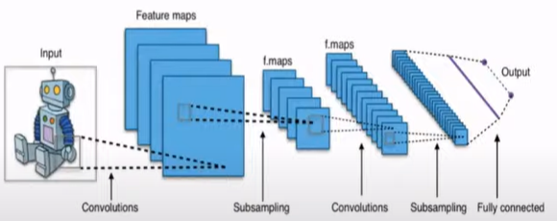

Fig 5.2.1 CNN Process Flow

**Steps For Building CNN Model**

1) Convolution Layer:

Convolution is the first layer to extract features from an input image. Convolution preserves the relationship between pixels by learning image features using small squares of the input data.it is a mathematical operation that takes two inputs such as an image matrix and a filter or kernel.

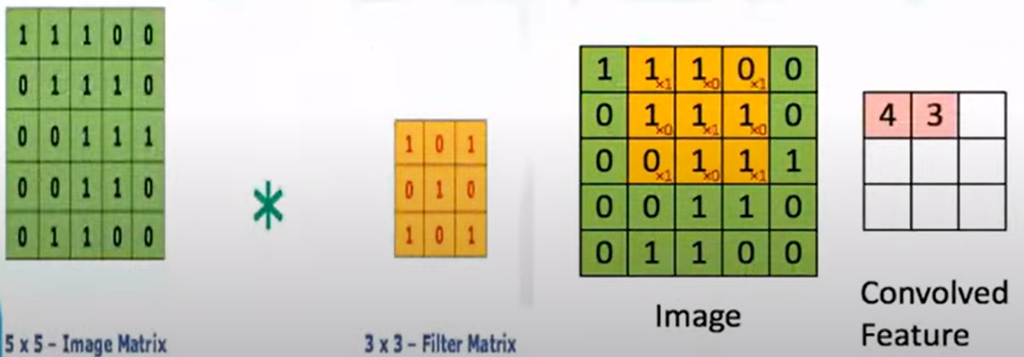

Fig 5.2.2 Convolution Layer

2) Pooling Layer:

Pooling layers are another way to reduce the size of the image interpretation to speed up computation, and it makes the detected features more robust. It allows you to determine features that produce the highest impact and reduces the risk of overfitting.

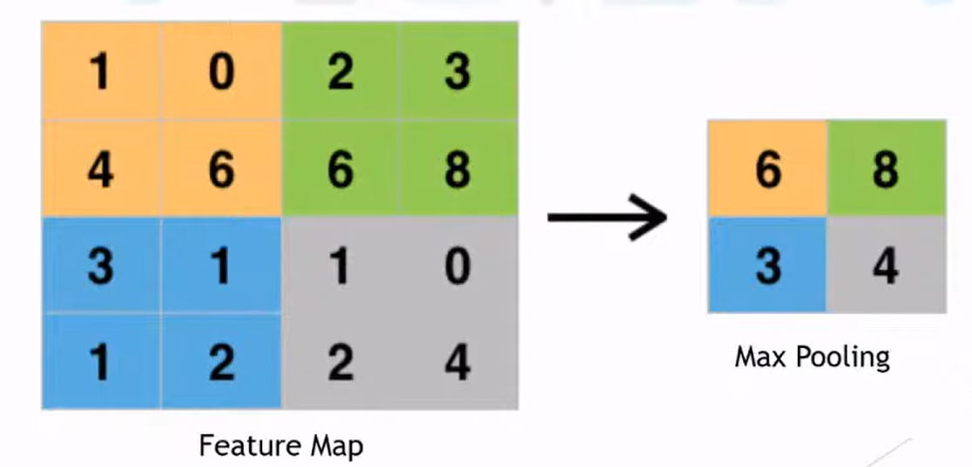

Fig 5.2.3 Pooling layer

3) Flattening Layer:

As the name of this step implies, we are going to flatten our pooled feature map into a column like in the image below. The reason we do this is that we’re going to need to insert the data into an artificial neural network

Fig 5.2.4 Flattening Layer

4) Full Connection:

A fully connected layer involves weights, biases, and neurons. It connects neurons in one layer to neurons in another layer. It is used to classify images between different categories by training.

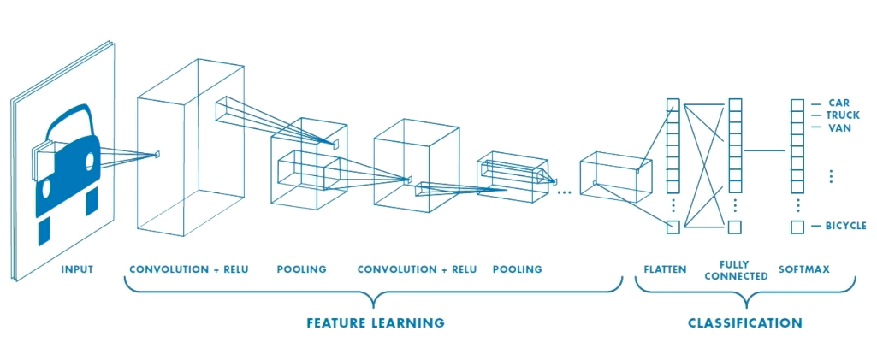

Fig 5.2.5 workflow of the model

# 5.3 Flowchart

# 

# Fig 5.3.1 Flow chart

# CHAPTER 6 IMPLEMENTATION

Compared to Regular Neural Networks, Convolutional Neural Networks have a different architecture. In

regular Neural Networks, it transforms an input by putting it through a series of hidden layers. Here every

layer is made up of a set of neurons, where each layer is fully connected to all neurons in the layer before.

Finally, there is an architecture i.e. a last fully-connected layer — the output layer — that represent the

predictions.

There are a bit different in Convolutional Neural Networks. At first, the layers are organized in 3 dimensions:

width, height and depth. Here, the neurons in one layer do not connect to all the neurons in the next layer

but only to a small region of it. Lastly, the final output of the system will be reduced to a single vector of

probability scores, organized along the depth dimension.

CNN is considered as two major parts:

**Feature Extraction:**

In feature extraction part, the network will perform a series of convolutions and pooling operations during

which the features are detected. If we had a picture of a tiger, this is the part where the network would

recognize its pelage, two ears, and four legs.

**Classification:**

In the case of classification, the fully connected layers will serve as a classifier on top of these extracted

features. Here, they will assign a probability for the object on the image being what the algorithm predicts it

is Fully Connected Layer (FC Layer) of Classification

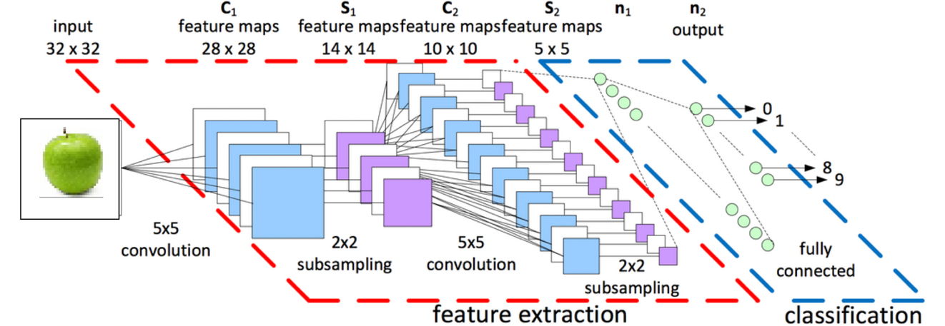

Fig 6.1 Convolutional Neural Networks architecture

Adding a Fully-Connected layer is a (usually) cheap way of learning non-linear combinations of the high-

level features as represented by the output of the convolutional layer. In that space, the Fully-Connected

layer is learning a possibly non-linear function.

Example of CNN network is given below:

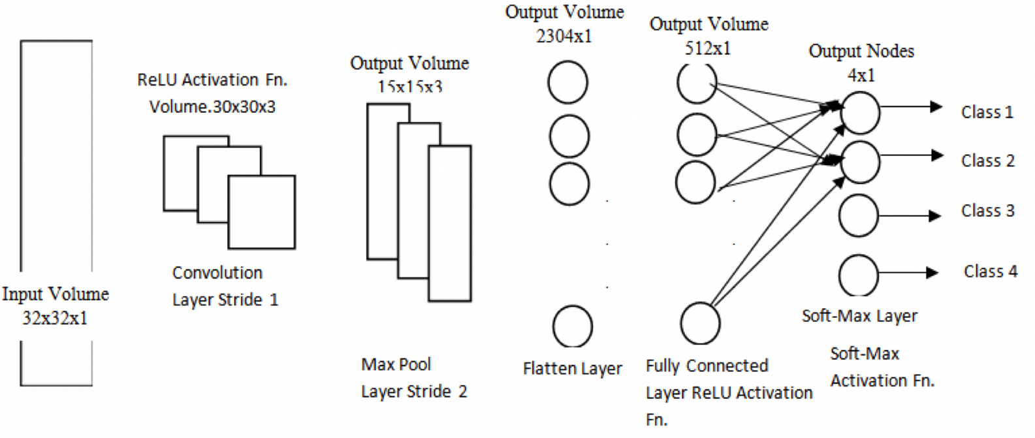

Fig 6.2 CNN

Here, the input images are converted into a suitable form and flattened the image into a column vector. Now

the flattened output is fed to a feed-forward neural network and is backpropagation applied to every iteration

of training. After a series of epochs, the model is able to differentiate between dominating and certain low-

level features in images and classify them using the SoftMax Classification technique.

All the components that are needed to build a CNN: Convolution, ReLU and Pooling. Here the output of max

pooling is fed into the classifier which is usually a multi-layer perceptron layer. In CNNs these layers are

used more than once i.e. Convolution ->ReLU -> Max-Pool -> Convolution ->ReLU -> Max-Pool and so on.

Now for the classification part, fully connected layer is used which involves ReLU->Dense->Soft-max and

so on. Throughout the study Convolutional Neural Network is used to justify images of fruits containing 4

different classes and achieved accuracy of 99.89%.

A block diagram is a short road map for that graphically represents how the data moves through the existing

system. The block diagram shown in figure 4.3 is used in design process. The block diagram provides

facilitating communication between us and user. It shows the input and output information i.e. what kinds of

information will be input to and output from the system, where the data will come from and go to, and where

the data will be stored. However it does not show information about the timing of processes but shows the

work procedure of the processes.

**6.1 Datasets**

The dataset created by the images captured by smart phone. This dataset of fruits which is categorized into

four classes. A challenging data set of 4 fruits categories, with 2403 real world images in total are introduced.

The images were collected from different fruit shops with various angles. It incorporates different yet in

addition outwardly and semantically comparative fruit classes where each class consists of 565 of image

among which 100 are manually reviewed test images and 465 are training images.

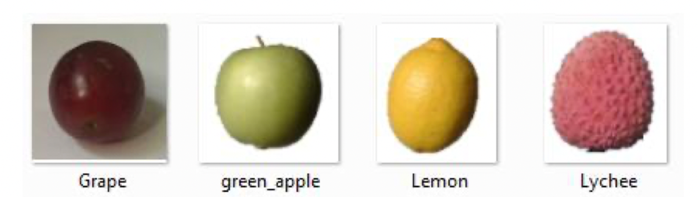

Fig 6.1.2 Dataset

**6.2 Pre-processing**

As the collection process of the data by smart phone the images were in different shape and sizes and training

a convolutional neural network on crude pictures will most likely lead to terrible classification exhibitions.

So the images are resized into square shape (256 x 256 pixel) and reduced unnecessary object from the

images.

**6.3 Data augmentation**

There is a popular theory goes around and that is the more data you have the better performance you get. As

a result data augmentation was built to produce more data artificially by handling some operations. For this

fruit recognition model augmentation can play a huge role which is beyond imagination. Here, the size of

data can be certainly multiply by twice. For data augmentation, each image is rotated by degree of 40, shifted

the width and height by 20% randomly, rescaled and zooms by 20%, flipped horizontally and shear with the

range of 20%.

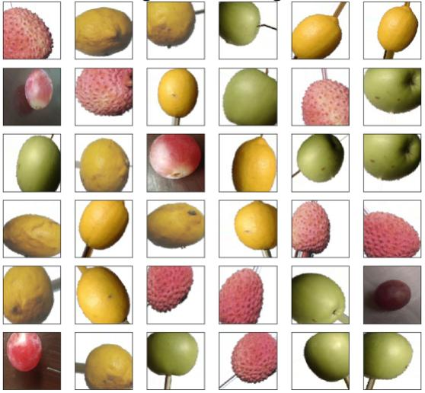

Fig 6.3 Augmented Images

**6.4Training the model**

The proposed model is trained on unique dataset that was collected from several places. Batch size of 30 was

used here. After 30 epochs the model achieves a satisfactory delicacy. The programmed learning rate

decrease recipe helps the analyser to meet quicker by keeping the learning rate decreased and after the

training process is done the rate or learning diminished by 0.0001 to1 × 10−6 .

**CHAPTER 7**

# RESULTS

In the proposed system, a model is introduced to recognize fruits from images. During this type of work, a

machine learning approach has developed to establish the model. In this study, a dataset of fruits of 4 classes

is introduced for recognition. To perform the task of the model, Convolutional Neural Networks (CNNs) is

used which was developed to perform on machine learning approaches. This model is able to get accuracy

of 99.89% which proved that the performance of this model to recognize fruits from images is more

advanced. The high accuracy of the model shows that CNN is very suitable for this kind of fruit recognition

and also found a great algorithm for CNN which has implemented successfully for recognition of fruits. The

optimized CNN's hyper parameters showed that CNN significantly improved the fruit recognition accuracy

compared with a conventional method using a support vector machine (SVM) with hand-crafted features .

we have applied a convolutional neural network on the fruits-360 dataset in order to find a better classification

performance of the network. For determining the overall classification accuracies, we have taken five cases

where we applied different combinations of hidden layers (convolution and pool) for 15 epochs with a mini-

batch size of 15 and calculated the accuracies on the test and training set.

**Training, Testing and the Validation of the model:**

To find out the performance of the model, separate training data, testing data and validation data is created.

The training dataset is used to train the model. During training time for checking the model performance

validation set is used which helped tuning the hyper-parameters of the model. The test data is used to finding

out the performance of final model. The dataset has total 2403 food images. Around 25% of images (569 in

total) used for validation and 75% of images (1834 in total) used to train the model. After the training is

completed, random images of fruit 5 in total is used. The validation data consisted of various fruit pictures.

To check the system validation, the images of validation data is used here. In this testing the model predicts

the data which class it belongs to. During this type of testing, all of the images of validation data have to be

cropped in 256×256 sizes.

To make the model more user friendly , we implemented a webpage where the user can access the functions

of the proposed system . This is a Simple Flask app fitted with Deep Conv. neural network model which is

able to distinguish between real-world images of Apples, Bananas, Oranges with predicting weather the fruit

in the image is Fresh or Rotten with respective probabilities.

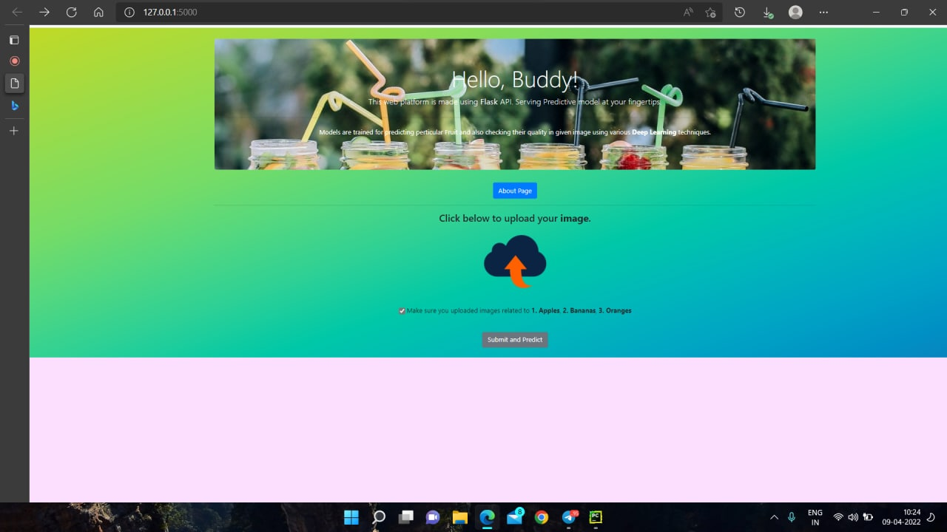

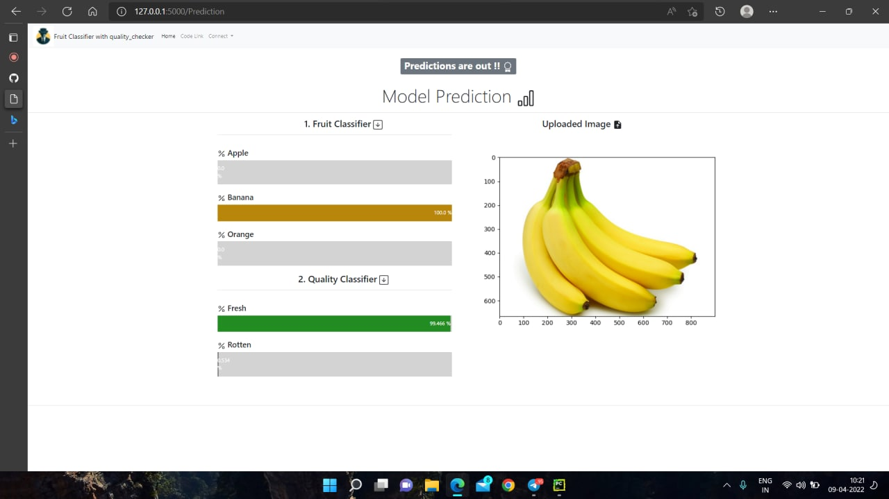Fig 7.1: Predicting model output

Fig 7.2 model output

# CHAPTER 8 CONCLUSION

This project explores a fruits recognition classifier based on the CNN algorithm. The accuracy and loss curves were generated by using various combinations of hidden layers for five cases using the fruits-360 dataset. The recognition rate has greatly improved throughout the experiment. This type of higher accuracy will cooperate to stimulate the overall performance of the machine more adequately in fruits recognition. On the contrary, the highest and the lowest performance loss were found without and with the presence of dropouts. This low loss will provide CNN with better performance to attain better fruit recognition. In the future, our plan is to perform the segmentation process on the image before recognition and then apply it on CNN. The applied CNN method is a very powerful method for machine learning approaches that successfully recognizes the fruits of images for the proposed model and the applied algorithm of CNN is successfully performed for image classification and object detection. In future, the existing database will be enhanced with various types of fruit images. Also future work will involves the integration of the proposed system for a variety of fruits to achieve more accurate performance that will be able to build a robotic harvesting system for fruits from orchards. A new method for classifying fruits using convolutional neural network algorithm is proposed. CNN better performance to attain better fruit classification.

# CHAPTER 9 FUTURE WORK

Hopefully, in the future, can be extended the work with a larger dataset having more categories fruits &

vegetables.. Have the plan to implement some other CNN based models to compare the accuracy on the

same dataset. Can be also work on some more features for grading and classification, which can identify

types of disease and/or texture structure of fruits. All these are future direction.

# CHAPTER 11 REFERENCES

[1]  Vartak, Akshay P., and Vijay Mankar. "Colour image segmentation-a survey." *International Journal of Emerging Technology and Advanced Engineering* 3, no. 2 (2013): 681-688.

[2] Dubey, Shiv Ram, and Anand Singh Jalal. "Application of image processing in fruit and vegetable analysis: a review." *Journal of Intelligent Systems* 24, no. 4 (2015): 405-424.

[3] Veerapur, Krutika A., and Ganesh V. Bhat. "Colour Object Tracking On Embedded Platform Using Open CV." *International Journal of Recent Technology and Engineering (IJRTE)* 2, no. 3 (2013).

[4] Xiaoyang Liu, Dean Zhao,Weikuan jia, Wei Ji, Yueping Sun, “A Detection Method for Apple Fruits Based on Color and Shape Features” , IEEE Access, 22

May 2019.

[5] Khatun, Mehenag, Forhad Ali, Nakib Aman Turzo, Julker Nine, and Pritom Sarker. "Fruits Classification using Convolutional Neural Network." *GRD Journals-Global Research and Development Journal for Engineering* 5, no. 8 (2020).

[6] Risdin, Fouzia, Pronab Kumar Mondal, and Kazi Mahmudul Hassan. "Convolutional neural networks (CNN) for detecting fruit information using machine learning techniques." *IOSR J. Comput. Eng.* 22 (2020): 1-13.

# [7] Image Classification on Dataset using Convolutional Neural Networks (CNN)

<https://www.analyticsvidhya.com/blog/2020/02/learn-image-classification-cnn-convolutional-neural-networks-3-datasets/>

[8] Fruit Classification And Quality Detection Using Deep Convolutional Neural Network

<https://www.electronicsforu.com/electronics-projects/electronics-design-guides/fruit-classification-quality-detection-using-deep-convolutional-neural-network>

# [9] Fruits Classification using Convolutional Neural Network

# https://www.researchgate.net/publication/343007822_Fruits_Classification_using_Convolutional_Neural_Network

[10] Implementation of Fruits Recognition Classifier using Convolutional Neural Network Algorithm for Observation of Accuracies for Various Hidden Layers